|  |  |
| --- | --- |
| TALLINN UNIVERSITY OF TECHNOLOGY | |
| School of Information Technologies | |
|  | |
|  | |
| Gleb Engalychev 206721IADB | |
| BOOKING WEB APP FOR A BEAUTY SALON NETWORK | |
| Building Distributed Systems  Project Scope | |
| Supervisor: | Andres Käver |
|  | Bachelor of Software Engineering |
|  |  |
|  |  |
|  |  |
|  |  |
|  |  |
|  |  |
|  |  |
|  |  |
|  |  |

Author’s declaration of originality

I hereby certify that I am the sole author of this thesis. All the used materials, references to the literature and the work of others have been referred to. This thesis has not been presented for examination anywhere else.

Author: Gleb Engalychev

20.02.2022

Table of contents

1 Introduction 5

1.1 Unregistered user positive flow 6

2 ERD schema 12

List of figures

Figure 1. Website main page 8

Figure 2. Book an appointment section 8

Figure 3. Salon services section 9

Figure 4. Log in page 9

Figure 5. Appointment booking form 10

Figure 6. Register page 10

Figure 7. Email verification message after registration 11

Figure 8. ERD schema 12

# Introduction

The main goal of the project is to create a webapp for a beauty branch business, where clients can comfortably register themselves on appointments. Currently this business, for which the app will be made, communicates with clients by phone and in social networks, where it promotes itself and makes appointments.

Now this model suits business well because its client base is small. It means that it is possible to consistently answer all phone calls and messages in social networks. However, when the business will expand, it won’t be possible anymore for someone to swiftly deal with all the clients.

Another fact that contributes to the described above problem is that clients tend to ask some additional information about business and its workers during appointment calls or conversations, like how much experience does someone have or what education did some of the workers get and etc.

To sum up, the problem is a requirement to spend a lot of time on talking with clients to make an appointment or provide them with additional information that they are interested in.

The solution is a web app, where clients will be able to register themselves on appointments without a need of them to contact someone from the business personal. In order to do this, every client will have to register themselves a profile on our website, where they will also be able to keep track of all their appointments.

There is also a need to create a client for a business owner, where it is possible to add working schedules for the people, who work on master positions. Appointment booking functionality will sync with schedules of masters and show available time slots on appropriate dates and time.

One of the strong advantages of this system is possibility to constantly monitor all available timeslots for the appointments. Consider following situation: today is a Monday and client A wants to register himself on a Friday, but currently all timeslots on Friday are occupied. However, it is still possible that someone will change their mind and cancel their appointment on a Friday. If this happens, client A will be able to take this time slot in a web client. Without this system client would have to call or text someone from business personal every day and wait for their answer, but with the system client can easily just visit the web page and check the info that is needed there. To motivate clients cancel their appointments if they know, that they will not appear, there will be a limit on how many booked appointments a client can have.

In addition to the already mentioned functionality, there will be more features such as: gallery tab, articles and section with information about working personal. In gallery section clients will be able to look at interior of all salons that our business owns and some works done by masters. In articles section there will be posts with some important information related to a beauty branch and jobs connected to it. Tab with an information about working personal will provide clients with all required information about masters that work in salons.

## Unregistered user positive flow

There are two possible scenarios of user positive flows when user navigates to a main page of a website. In first scenario, user is logged in and in second he is not. Further a second scenario will be demonstrated and commented first, because first scenario contains all steps listed in second scenario.

When user first time enters the website, he will see a main page. It consists of navigation bar on top of the screen which is a part of every website page and main page content (currently it is planned to be a promo video) as displayed in a Figure 1 below. Navbar consist of multiple elements, which are:

* Business logo
* Gallery button, which redirects user to a gallery section. There are photos of every salon and some works
* About us button, which redirects user to a about us section. It contains multiple blogposts of some salon masters, where they describe themselves and their works, so the potential clients can get familiar with business personal
* Articles button, which redirects user to a articles section. It contains informative articles related to a beauty branch
* Services button, which redirects user to a services section. There user can look at services that business provides by salon and prices for them
* Contact button, which redirects user to a contact section. This section shows all ways to contact our business by salon
* Book an appointment button, which redirects user to a book an appointment section. There will be shown a list of salons, where user chooses the one he wants to visits and books an appointment there
* Social networks buttons, which redirect user to business groups in social networks

Further elements of navbar appear only then when user is logged out:

* Log in button, which redirects user to a log in section. It contains form, which allows user to log into an existing account
* Register button, which redirects user to a register section. It contains form, which allows user to register a new account

Figure 1. Website main page

Figure 2. Book an appointment section

From book an appointment section (Figure 2) user then can view services of a certain salon (Figure 3) or proceed to booking an appointment in chosen salon, which will redirect him to a log in page (Figure 4), because he is not logged in. If user chooses to book an appointment on a certain service in a service section, he will also be redirected to a log in page.

Figure 3. Salon services section

Figure 4. Log in page

If user logs in, he will be redirected to a page with an appointment booking form, where he will be able to book an appointment for a suitable for him time (Figure 5). If user decides to register a new account, he will be redirected to a page with a register form (Figure 6). After inputting all required data into register form and confirming it, user will be redirected to a page with an informative message, which will ask user to verify his email address (Figure 7). After successful email verification, user will be redirected to a page with an appointment booking form. If user choosen before to book a certain appointment from a salon services page, services field in the form will be prefield with choosen service.

Figure 5. Appointment booking form

Figure 6. Register page

Figure 7. Email verification message after registration

After booking an appointment, user will be redirected back to the main page (Figure 1).

# ERD schema

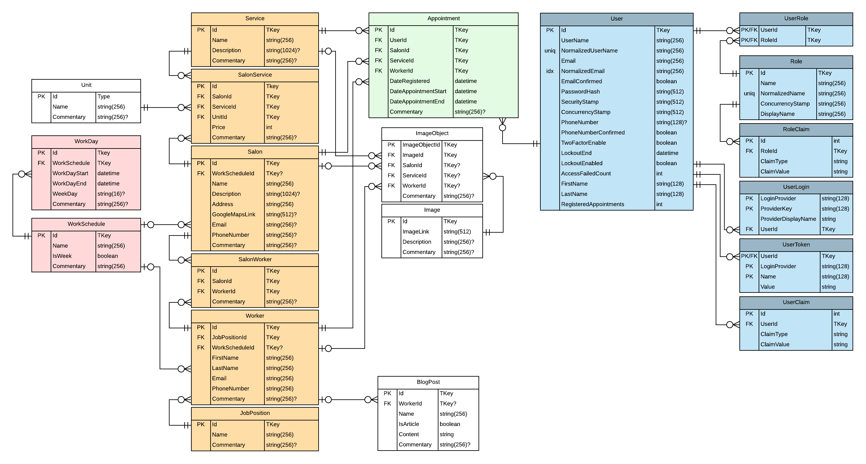

Figure 8. ERD schema